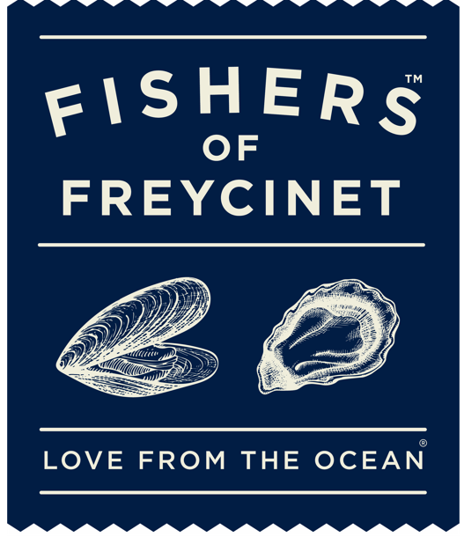

Oysters
Freycinet Marine Farm Oysters ‘Natural’
W/ Lemon
6ea $17 | 12ea $30
Freycinet Marine Farm Oysters ‘French Classic‘
Sauce Mignonette
6ea $17 | 12ea $34
Freycinet Marine Farm Oysters ‘Panoramic’
Sauce Mignonette | Salmon Roe, Native Finger Lime + Cucumber Salsa | Gazpacho Dressing
6ea $18 | 12ea $35
Freycinet Marine Farm Oysters ‘Ponzu’
Steamed with Soy + Mirin + Ginger
6ea $18 | 12ea $35
Freycinet Marine Farm Oysters ‘Devilish’
Grilled with Spicey Chorizo + Tomato + Sherry Vinegar
6ea $18 | 12ea $36

Tasmanian Blue Mussels
Freycinet Marine Farm Mussels ‘Fragrant Thai Curry’
Thai Style Aromatic Coconut Curry
$30
Freycinet Marine Farm Mussels ‘Moules Mariniere’
White Wine + Garlic + Herbs + Cream
$30

Fish + Chips
Local Line Caught Fish in Crisp Beer Batter + Chips + Tartare Sauce + Lemon
$28

Shared Plates
The Tasman Plate
Natural Oysters | Mussels and Octopus Antipasto | Smoked Salmon Pate | Crusty Bread
(shared plate for two) $55

The Fishers Plate
Natural Oysters | Smoked Ocean Trout + Remoulade Salad | Mussels and Octopus Antipasto
Wild Australian King Prawns + Coral Sauce | Crusty Bread | Garden Salad
(shared plate for two) $75

Note: There maybe menu changes or pricing differences due to seasonality and availability.

